A SHARED PASSION THE WAY OF LIFE
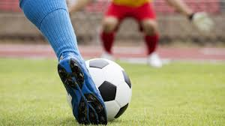

FOOTBALL
POPULARITY UNPREDICTABILITY SPORT FOR EVERYONE

FOOTBALL – THE PHENOMENON OF SPORTS

Football is absolutely the most popular sport in Poland. As well as it is a truly global sport. Most boys play football in our country. They do it either outside the home or on the computer. If you run fast, you can start playing football at the age of several years.
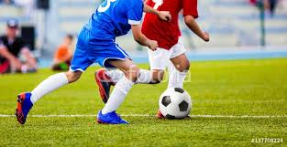

Difficult beginnings
The growing popularity of this game
- street was the place of brutal game
- there were victims during the game

1314 Edward II: A ban on playing football
No rules for competition
- public school wanted to compete
- school representatives meeting
1848 Rules & Regulations

First teams – first matches
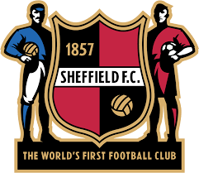
1855 The first football club

1872 The first international match
1900 The first team discipline of the Olympic Games

Cups – tournaments – titles

The most successful team
National:
Brazil 5x world champions ★★★★★
Italy 4x world champions ★★★★
Germany 4x world champions ★★★★
Club:
Real Madrid 13x champions league winners ★★★★★★★★★★★★★
AC Milan 7x champions league winners ★★★★★★★
FC Barcelona 5x champions league winners ★★★★★
Why is it so popular???
31,6 million have watched at least one match of the last World Cup in Poland
250 million registered players in the world
1,3 billion people watched the finals in France on TV
Simple rules
Sport for everyone
Great stadiums
Beautiful goals
Football virtuosos
Unpredictability
,,As long as the ball is in play, everything is possible’’
Kazimierz Górski
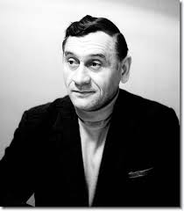

PHENOMENON

The most popular sport in 126 countries
Half of the population for once played football
The most popular sport in the world
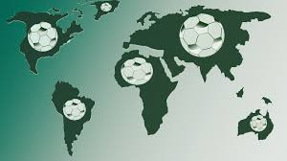

UPS & DOWNS
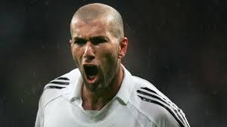
Zinedine Yazid Zidane
- presecution
- passion: football
- ‘the virtuoso’
- one of the most expensive football player
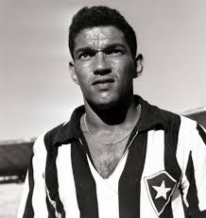
Garrincha
- disability
- passion: football
- king of dribbling
- ,,What planet is Garrincha from?’’
Diego Armando Maradona
- Maradona was addicted to cocaine
,,I was, I am and I always will be a drug addict. A person who gets involved in always has to fight it every day’’
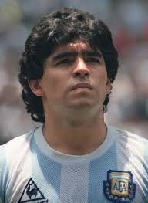
D.M.

There is only one king
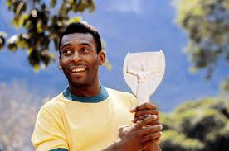
- the youngest world champion
- world champion 1958 1962 1970
,, I was born to play football, just like Beethoven was born to write music and Michelangelo was born to paint.’’

PELE

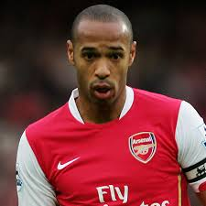
,,I eat football,
I sleep fooyball,
I breathe football,
I’m not mad,
I’m just pasionate.”
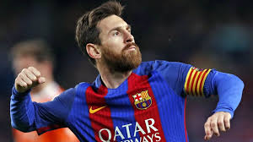
Thierry Henry
,,There’s no doubt. It’s certain
That I’ll be 100 percent.’’
Lionel Messi
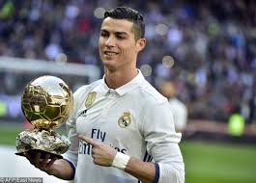
,,We don’t want to tell our dreams.
We want to show them.’’
Cristiano Ronaldo

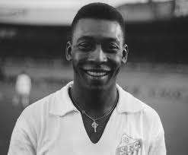
,,I am constantly being asked about
Individuals. The only way to win is as
a team. Football is not about one or two
or three star players.’’
Pele
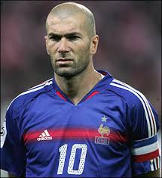
,,I once cried because I had no
shoes to play football with my
friends, but one day I saw a man
who had no feet, and I realized
how rich I am.’’
Zinedine Zidane

Football fans
